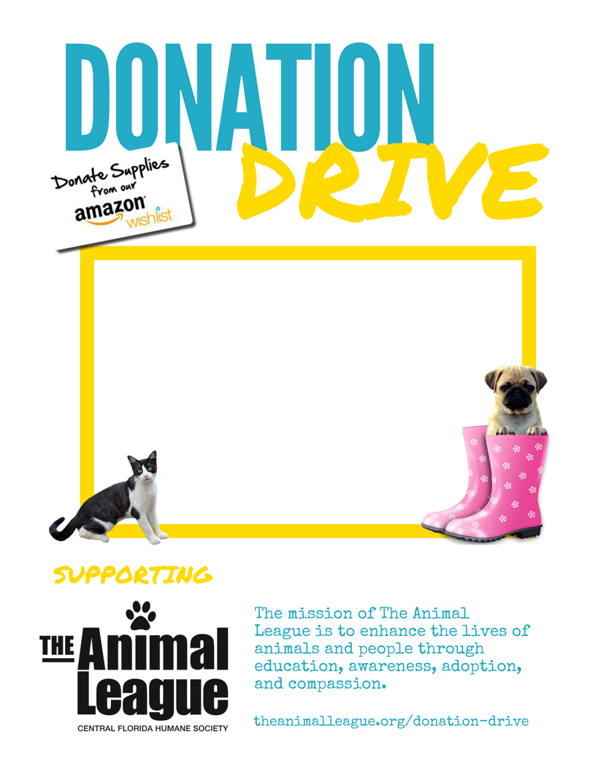

Directions: 1. Delete these instructions and replace with your donation drive details (your organization name, date/time of donation drive collection, etc.). 2. Print your flyer and share. 3. Save your flyer as an image file (e.g., jpg or png) and share on your social media sites! Thank you for supporting The Animal League.