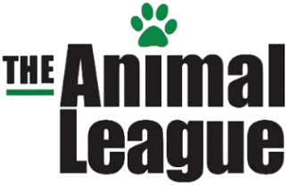
13TH ANNUAL HOWL-O-WEEN
Pet Parade & Costume Contest
The Animal League is very happy to once again host our favorite Halloween tradition, the annual Howl-O-ween Pet Parade and Costume Contest. This highly anticipated parade is a family friendly event that community pet owners look forward to each year. As a valued business member in the community and friend to the animals, we hope that you will consider a sponsorship to support this fun event being held on October 31, 2021 during Clermont’s Farmers Market in downtown Clermont.

In order to continue our efforts to support the welfare of the animals of Central Florida, we need the assistance of our community and its leaders. We have lined up a spooktacular array of opportunities for you to choose from to make this our best year ever.

The sponsorship level you select is completely up to you! Of course, any donation amount will be gratefully accepted! So, throw on your Halloween costume, grab your candy bag and get ready for one of Clermont’s favorite traditions.
Sponsor  Benefits | Furry Friend  Level  $125.00 | Pet Protector  Level  $250 | Best in Show  Level  $500 | Pedigree  Level  $750
Company name/Logo Prominently displayed at event. | 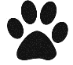 | 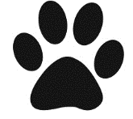 | Company Logo Included | Company Logo Included
Free vote(s) for the “People’s Choice” Award | 1 Vote | 2 Votes | 3 Votes | 5 Votes
Listed on The Animal League Website & Social Media |  |  | Company Logo Included | Company Logo Included
Announcements featuring your business before, during and after the Parade
Blanket Sponsorship(s) in your company name |  |  | 1 Blanket | 2 Blankets
Choice of participating as an Honorary Judge or Leading the Parade |  |  | 1 Judge | 2 Judges
A copy of the official registration (#CH2848) and financial information may be obtained from the Division of Consumer Services by calling 1-800-435-7352 within the state. Registration does not imply endorsement, approval, or recommendation by the state.
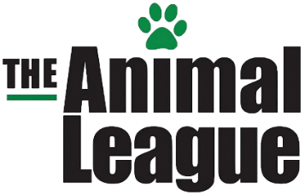
13th Annual HOWL-O-WEEN Pet Parade & Costume Contest Sponsor Application
must be submitted by October 22, 2021
Business Name:
Contact Person:
Mailing Address:
City, State, Zip:
Email:
Work phone: Cell Phone:
Website URL:

Payment Method: ___Cash ____Check ____Credit Card (Amex, Visa, MC)
______ $125 Furry Friend Level
______ $250 Pet Protector Level
______ $500 Best in Show Level
______ $750 Pedigree Level

ALL SPONSORS-PLEASE EMAIL YOUR LOGO IN HIGH QUALITY JPG FORMAT TO EVENTS@THEANIMALLEAGUE.ORG

Please visit https://theanimalleague.org/howl-o-ween-pet-parade-costume-contest-2021/ to pay via debit/credit card online. Checks must be submitted IN PERSON to the event coordinator or Howl-O-Ween representative. Contact Deb Munini Schwartz (event coordinator) at 407-701-1096 or events@theanimalleague.org for over the phone payment or to make arrangements for in person payment.

